銷售探索

--這是由 RDS系統自動生成的報告

--作者: lin wai ting

# 1.(KDD1) 擷取數據 (-->X)

* 數據日期: 01.01.2013 - 31.12.2014
* 交易筆數: 1221451 筆紀錄
* 交易數據樣貌 --

|  |  |  |  |  |  |  |  |  |
| --- | --- | --- | --- | --- | --- | --- | --- | --- |
| index | date | date_block_num | shop_id | item_id | item_price | item_cnt_day | year | month |
| 0 | 02.01.2013 | 0 | 59 | 22154 | 999.0 | 1.0 | 2013 | 01 |
| 10 | 03.01.2013 | 0 | 25 | 2574 | 399.0 | 2.0 | 2013 | 01 |
| 11 | 05.01.2013 | 0 | 25 | 2574 | 399.0 | 1.0 | 2013 | 01 |

# 2.(KDD2) 數據探索 (X)

* 歷年銷售數據(銷售量/月): --

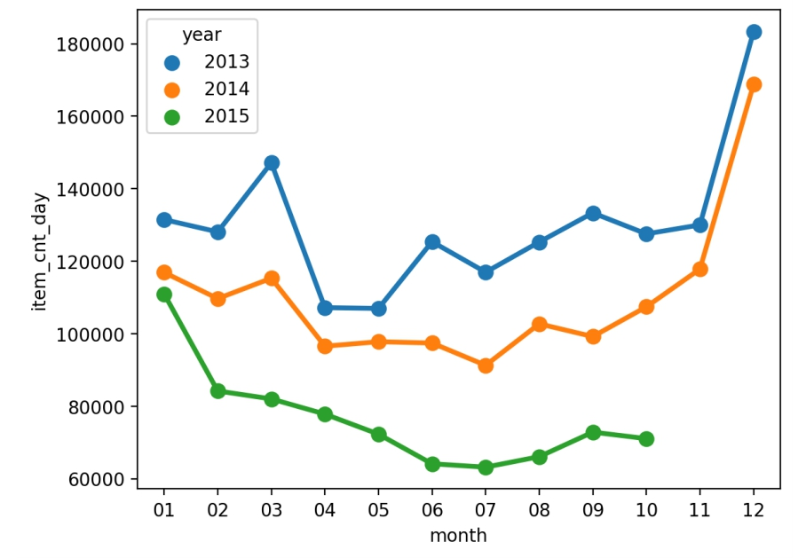

以整體銷售量數據來看

1.售出的商品數量有逐年減少的趨勢

2.在接近年尾時商品賣得較好

3.年尾是銷售量最高

* 歷年銷售數據(銷售金額/月): --

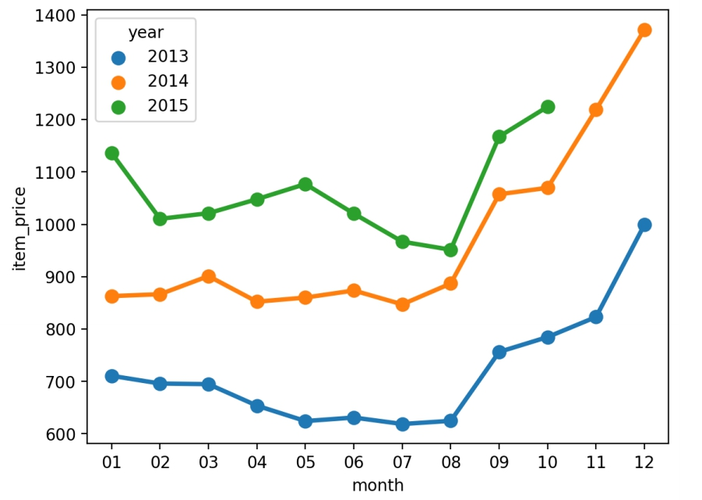

以整體銷售額數據來看

1.售出的商品價格逐年提高

2.每年8-9月金額增加幅度大

3.年尾是銷售額最高

* 連續月份銷量數據(銷售量/連續月份): --

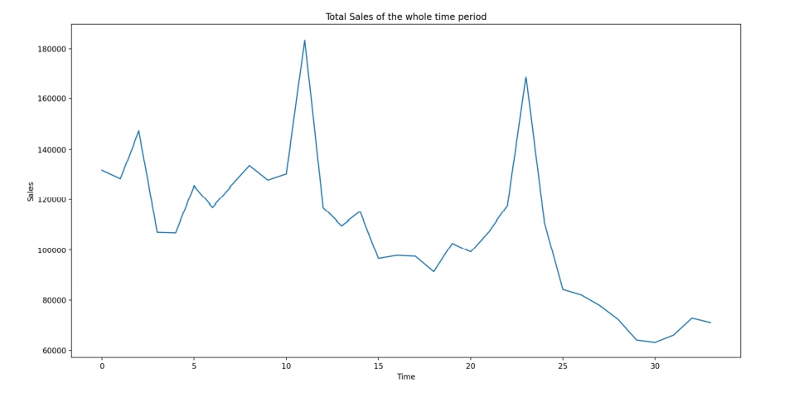

以連續月份銷售量來看

1.銷售量逐年下降

2.春夏之間銷量低迷

3.年底是銷量高峰

* 價格與銷量分布圖: --

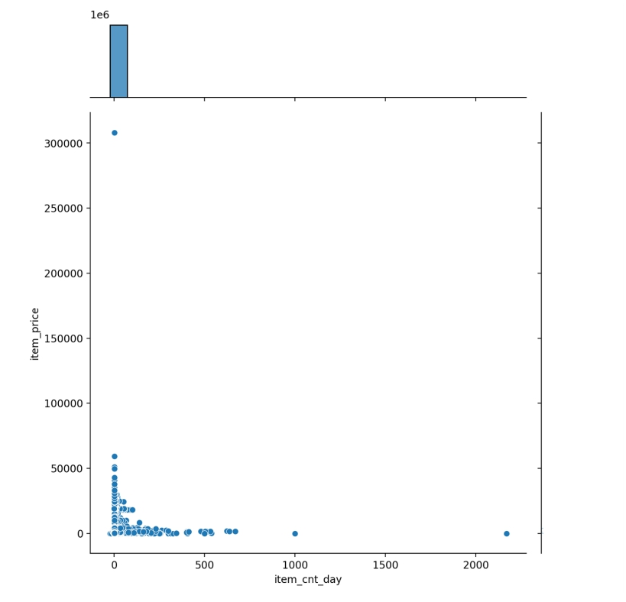

以價格與銷量分布圖來看

1.價格帶主要落在0~50000之間

2.單筆交易數量主要落在0~500之間

小結

1.年尾銷售量銷售額都比較高

2.銷售量逐年下降

3.銷售額逐年上升

4.銷售量下降,銷售額卻上升 -> 價格提高 -> 俄羅斯金融風暴

# 2.(KDD3) 通路聚類 (X)

* 通路A: 共 31 家通路

|  |  |  |  |  |  |
| --- | --- | --- | --- | --- | --- |
| index | shop_id | item_cnt_day | item_price | group | one |
| 2 | 2.0 | 30620.0 | 35104442.431943074 | 0.0 | 1146.4546842567954 |
| 4 | 4.0 | 43942.0 | 35335390.716130696 | 0.0 | 804.1370605828296 |
| 5 | 5.0 | 42762.0 | 33260876.502807736 | 0.0 | 777.8138651795458 |
| 6 | 6.0 | 100489.0 | 74558314.78033832 | 0.0 | 741.9549879124911 |
| 7 | 7.0 | 67058.0 | 56077104.693169564 | 0.0 | 836.2477958359863 |
| 12 | 12.0 | 73478.0 | 50805586.28515201 | 0.0 | 691.4394279260732 |
| 14 | 14.0 | 46375.0 | 36006448.21340467 | 0.0 | 776.4193684831196 |
| 15 | 15.0 | 71201.0 | 55597585.54840827 | 0.0 | 780.8539985169909 |
| 16 | 16.0 | 61633.0 | 48712980.14163863 | 0.0 | 790.3717187487 |
| 18 | 18.0 | 65486.0 | 62516425.594277166 | 0.0 | 954.6532937464063 |
| 19 | 19.0 | 73455.0 | 54302000.47344708 | 0.0 | 739.25533283571 |
| 21 | 21.0 | 68560.0 | 51479368.96214663 | 0.0 | 750.8659416882531 |
| 22 | 22.0 | 60230.0 | 42245136.8640332 | 0.0 | 701.3969261835165 |
| 24 | 24.0 | 63886.0 | 56288283.554323666 | 0.0 | 881.0738433197205 |
| 26 | 26.0 | 67890.0 | 48516115.783850595 | 0.0 | 714.6283073184651 |
| 29 | 29.0 | 58713.0 | 45287705.20448399 | 0.0 | 771.3403369693934 |
| 30 | 30.0 | 60828.0 | 38858922.904906906 | 0.0 | 638.8328221363008 |
| 35 | 35.0 | 69016.0 | 56823122.3685533 | 0.0 | 823.3325948845674 |
| 37 | 37.0 | 46256.0 | 37348676.881571144 | 0.0 | 807.4342113795215 |
| 38 | 38.0 | 53886.0 | 53603251.97605458 | 0.0 | 994.7528481619452 |
| 41 | 41.0 | 49324.0 | 38283700.491037615 | 0.0 | 776.1677984558758 |
| 43 | 43.0 | 50608.0 | 42751502.78511699 | 0.0 | 844.7578008440759 |
| 45 | 45.0 | 41895.0 | 33778798.815648384 | 0.0 | 806.2727966499197 |
| 46 | 46.0 | 78990.0 | 60934691.48983313 | 0.0 | 771.422857195001 |
| 47 | 47.0 | 67637.0 | 62805222.2300766 | 0.0 | 928.5630975660748 |
| 50 | 50.0 | 76238.0 | 63356951.985280216 | 0.0 | 831.0416325884757 |
| 52 | 52.0 | 49744.0 | 37649122.96175876 | 0.0 | 756.8575699935421 |
| 53 | 53.0 | 61657.0 | 47928860.901970685 | 0.0 | 777.346625719232 |
| 56 | 56.0 | 78079.0 | 51696380.36846388 | 0.0 | 662.1035152661264 |
| 58 | 58.0 | 81734.0 | 58463438.2534406 | 0.0 | 715.289087202885 |
| 59 | 59.0 | 48993.0 | 37264789.50717923 | 0.0 | 760.6145675337136 |

高單價通路:

* 單價區間: 638.8328221363008 - 1146.4546842567954
* 單價平均: 798.51
* 銷量區間: 30620.0 - 100489.0
* 銷量平均: 61634.29
* 總銷售額區間: 33260876.502807736 - 74558314.78033832
* 總銷售額平均: 48633587.09
* 通路B: 共 7 家通路

|  |  |  |  |  |  |
| --- | --- | --- | --- | --- | --- |
| index | shop_id | item_cnt_day | item_price | group | one |
| 25 | 25.0 | 241920.0 | 155557554.00897828 | 1.0 | 643.012376029176 |
| 27 | 27.0 | 136657.0 | 105648893.1093601 | 1.0 | 773.0953636429902 |
| 28 | 28.0 | 184557.0 | 125294703.5110426 | 1.0 | 678.8943443545495 |
| 31 | 31.0 | 310777.0 | 170763434.32635823 | 1.0 | 549.472561760871 |
| 42 | 42.0 | 144934.0 | 101551476.97287701 | 1.0 | 700.6739410550803 |
| 54 | 54.0 | 185790.0 | 109669430.19037895 | 1.0 | 590.2870455373214 |
| 57 | 57.0 | 141107.0 | 91315213.03045203 | 1.0 | 647.1345364188313 |

高銷量通路:

* 單價區間: 549.472561760871 - 773.0953636429902
* 單價平均: 654.65
* 銷量區間: 136657.0 - 310777.0
* 銷量平均: 192248.86
* 總銷售額區間: 91315213.03045203 - 170763434.32635823
* 總銷售額平均: 122828672.16
* 通路C: 共 22 家通路

|  |  |  |  |  |  |
| --- | --- | --- | --- | --- | --- |
| index | shop_id | item_cnt_day | item_price | group | one |
| 0 | 0.0 | 11705.0 | 5553869.0 | 2.0 | 474.48688594617687 |
| 1 | 1.0 | 6311.0 | 2926161.0 | 2.0 | 463.66043416257327 |
| 3 | 3.0 | 28355.0 | 26472615.079570357 | 2.0 | 933.6136511927475 |
| 8 | 8.0 | 3595.0 | 2226272.705 | 2.0 | 619.269180806676 |
| 9 | 9.0 | 15866.0 | 4714302.740834122 | 2.0 | 297.13240519564613 |
| 10 | 10.0 | 24523.0 | 16442844.229999935 | 2.0 | 670.5070435917276 |
| 11 | 11.0 | 572.0 | 479842.45999999985 | 2.0 | 838.8854195804194 |
| 13 | 13.0 | 19763.0 | 5333601.480000007 | 2.0 | 269.8781298385876 |
| 17 | 17.0 | 25838.0 | 23521670.123488043 | 2.0 | 910.3518121947535 |
| 20 | 20.0 | 5872.0 | 2389265.927055682 | 2.0 | 406.89133635144447 |
| 23 | 23.0 | 7705.0 | 5023141.846071436 | 2.0 | 651.9327509502189 |
| 32 | 32.0 | 8781.0 | 5098651.531581204 | 2.0 | 580.6458867533544 |
| 33 | 33.0 | 5482.0 | 5594079.520238099 | 2.0 | 1020.4450055158882 |
| 34 | 34.0 | 6451.0 | 7695497.419935061 | 2.0 | 1192.9154270555048 |
| 36 | 36.0 | 330.0 | 356819.0 | 2.0 | 1081.269696969697 |
| 39 | 39.0 | 16617.0 | 15012388.966012983 | 2.0 | 903.435575977191 |
| 40 | 40.0 | 4943.0 | 4080156.3199999994 | 2.0 | 825.4412947602669 |
| 44 | 44.0 | 44938.0 | 29419582.061186437 | 2.0 | 654.6704806886474 |
| 48 | 48.0 | 24909.0 | 24298218.997164097 | 2.0 | 975.4795052858042 |
| 49 | 49.0 | 17090.0 | 18338237.20452383 | 2.0 | 1073.0390406391944 |
| 51 | 51.0 | 48767.0 | 21855590.099999964 | 2.0 | 448.1635142616926 |
| 55 | 55.0 | 63388.0 | 21135859.83066312 | 2.0 | 333.4362944194977 |

一般通路:

* 單價區間: 269.8781298385876 - 1192.9154270555048
* 單價平均: 710.25
* 銷量區間: 330.0 - 63388.0
* 銷量平均: 17809.14
* 總銷售額區間: 356819.0 - 29419582.061186437
* 總銷售額平均: 11271303.07

以通路聚類來看

1.高銷量通路平均總銷售額較高

2.高單價通路雖然單價比一般通路高，但平均銷售數也比較一般通路高

3.高銷量通路平均總銷售額明顯較高